**Practice lab details**

**Step 1a**: Click on the link below

[Activity Details - SumTotal](https://cognizantlearning.sumtotal.host/rcore/c/pillarRedirect?isDeepLink=1&relyingParty=LM&url=https%3A%2F%2FCOGNIZANTLEARNING.sumtotal.host%2Flearning%2Fcore%2Factivitydetails%2FViewActivityDetails%3FUserMode%3D0%26ActivityId%3D1181277%26ClassUnderStruct%3DFalse%26CallerUrl%3D%2Flearning%2Flearner%2FHome%2FGoToPortal%3Fkey%3D0%26SearchCallerURL%3Dhttps%253A%252F%252FCOGNIZANTLEARNING.sumtotal.host%252Fcore%252FsearchRedirect%253FViewType%253DList%2526SearchText%253DCTHMZ031743%2526startRow%253D0%26SearchCallerID%3D2)

**(or)**

**Step 1b**:

• **Login to** <https://cognizantlearning.sumtotal.host/core/search>

• Enter the course code **CTHWD272297** and navigate to **Web Development Lab [201-INTERMEDIATE]**

**Step 2**: Click on **Register**

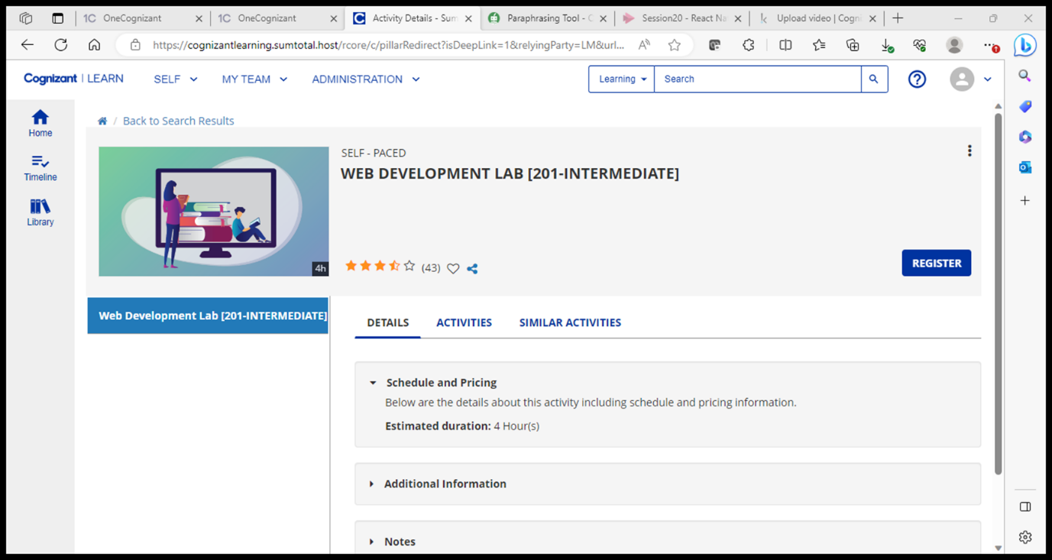

**Step 3**: Confirm registration by clicking **REGISTER** again

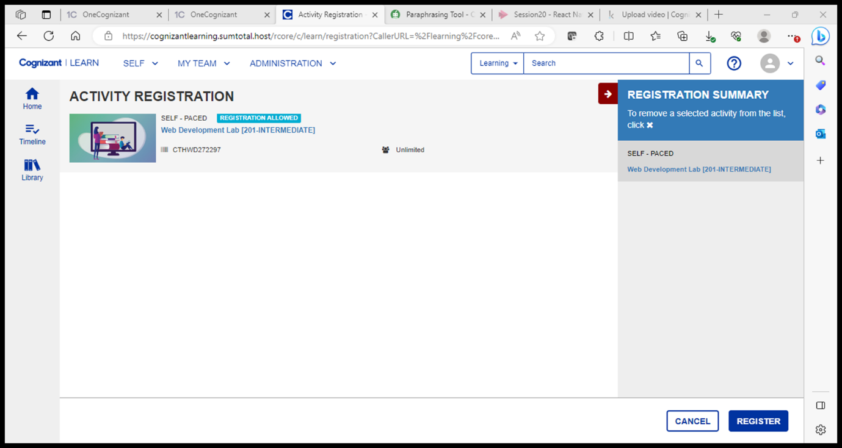

**Step 4**: Post registration, click on **START** to launch Virtual Machine.

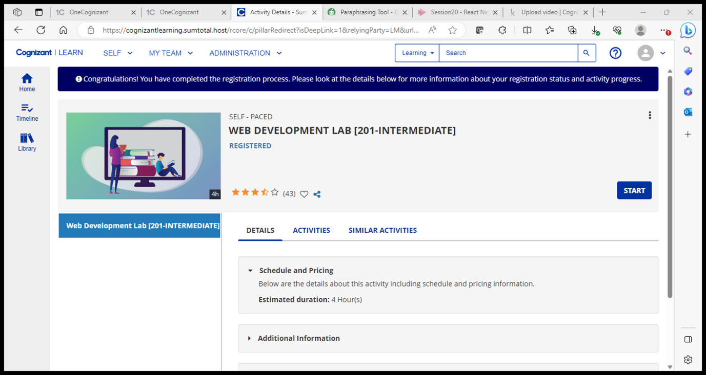

**Step 4**: VM will launch in a separate browser window *(Process may take ~141 seconds & during peak hours, may take more time as well).*

*Click on Cancel*

*And then click on Skip for now Don’t enter any credentials.*

**Note:**

* VM will be enabled for 3 hours and 30 minutes with an extension of 30 more minutes (Total 4 hours)
* Labs can be launched multiple times a day
* Google Chrome browser works best.
* Use GIT to save the files prior to closing each lab session. GIT usage details can be viewed as per below screenshot.

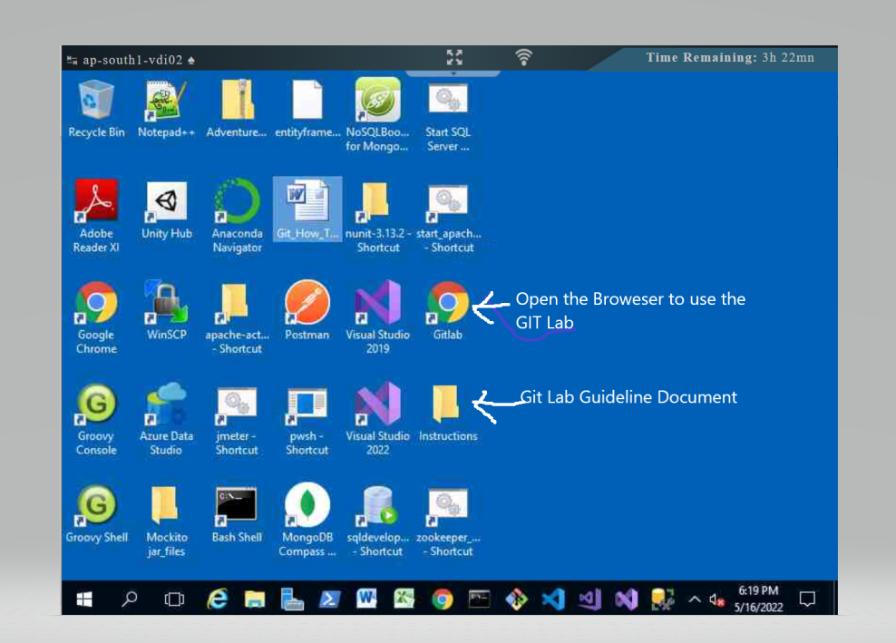

If you have any specific queries, please feel free to reach out to me – **Nihan Shaikh (682905)**